**Initial Project Description and Work Plan**

**Introduction:**

In this project I plan to create an image search engine that will take an image from a user’s input and compare its characteristics against a gallery of locally stored images to determine which are the most similar. The images which are deemed to be most similar will be displayed to the user. From here the user can close the application or they can choose to clear the data and chose another image to search. A possible user interface is shown below in Fig. 1

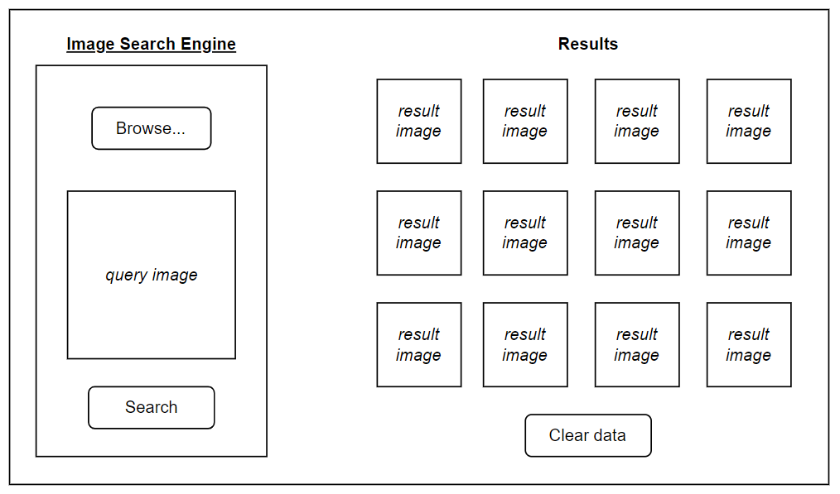

**Fig. 1** Possible GUI

**Marking Criteria/ Requirements:**

* Allows user to select a query image and show it in GUI
* Implement effective distance measurement for colour, texture, and shape
* Apply functions to query image
* Iterate through images in gallery and apply functions to each image
* Returns multiple images from gallery that are similar based on distance measurement (top 12 images that are closest)(perhaps less if some are closest but still not close)
* Create GUI with buttons for image selection, search, and clear data

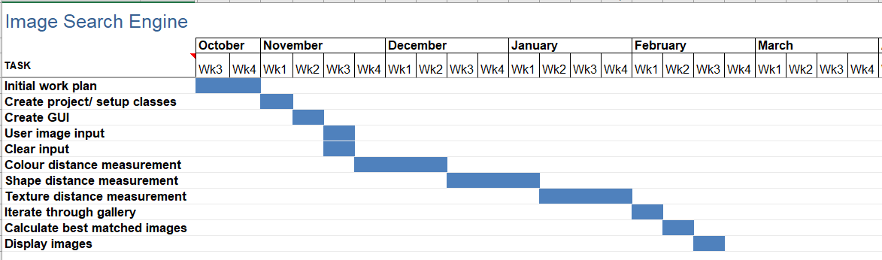**Gantt Chart:**

**Goals:**

Compare using distance measurements

Colour:

* colour histogram (*primary)*
* segment colour proportion by region and by spatial relationship among several colour regions (*secondary*) *optional addition, time/ result dependent*

Texture: two-dimensional grey level variation

Shape: segmentation or edge detection

**GitHub:**

<https://github.com/acregan04/ImageSearchEngine.git>

**Software:** MATLAB

I have been using MATLAB in another module this year and have experience doing image processing, so I know this is a suitable piece of software to complete this project.

**Testing**

Correlation

1. 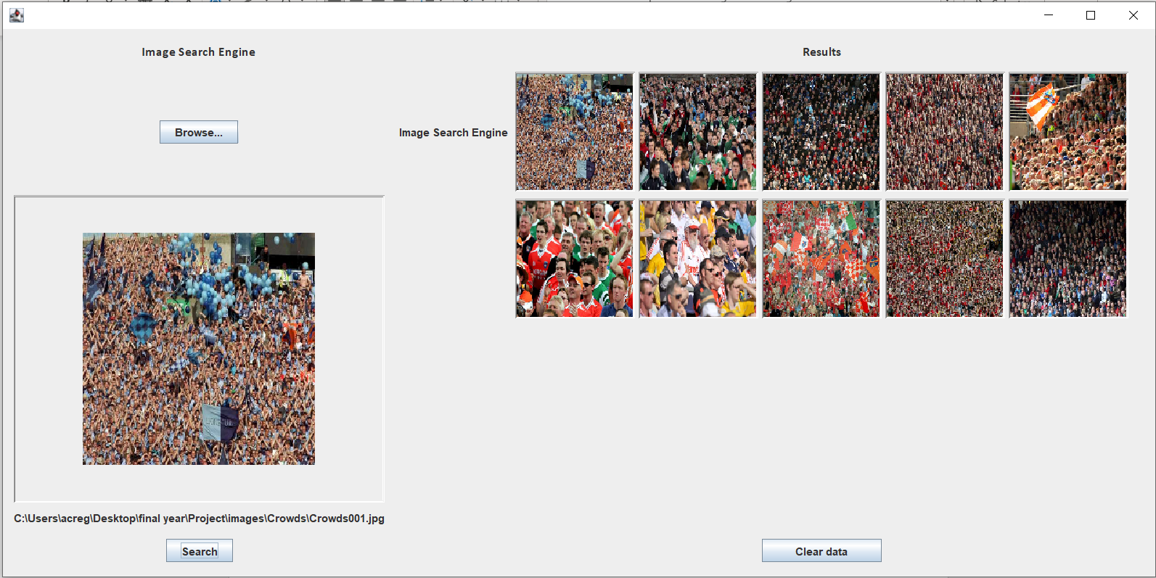
2. 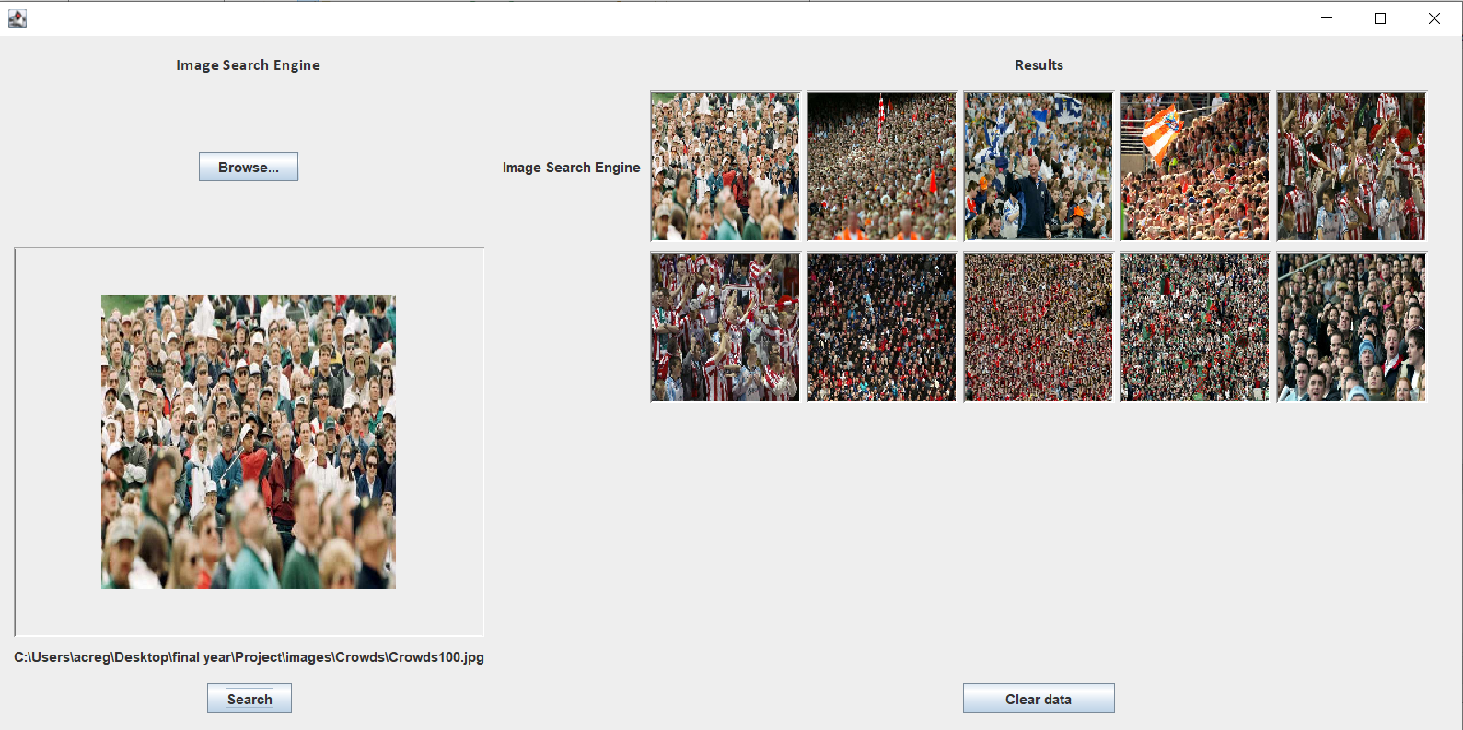
3. 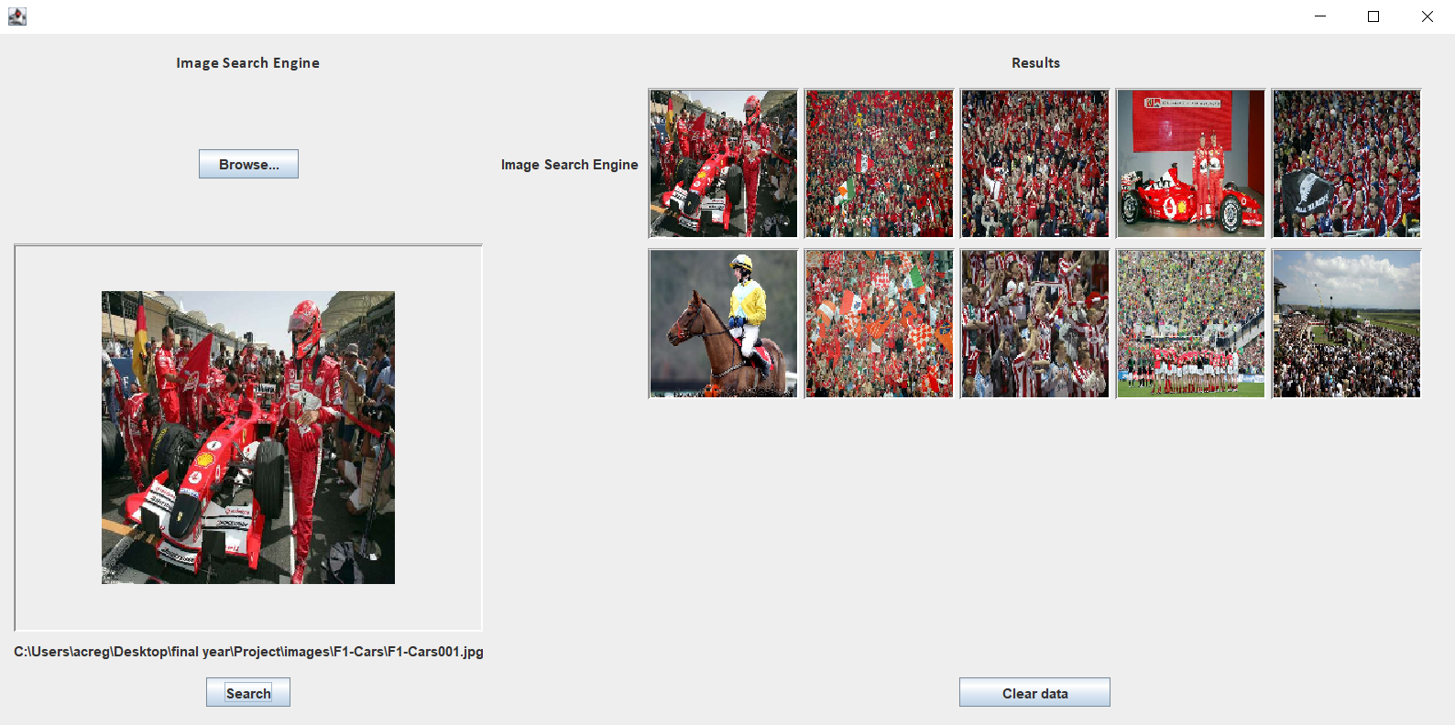
4. 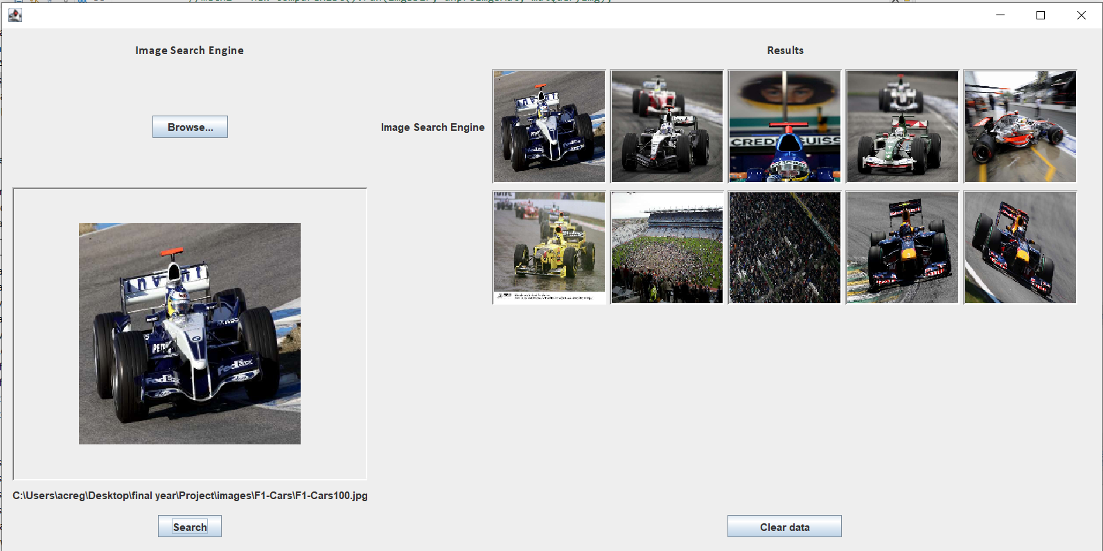
5. 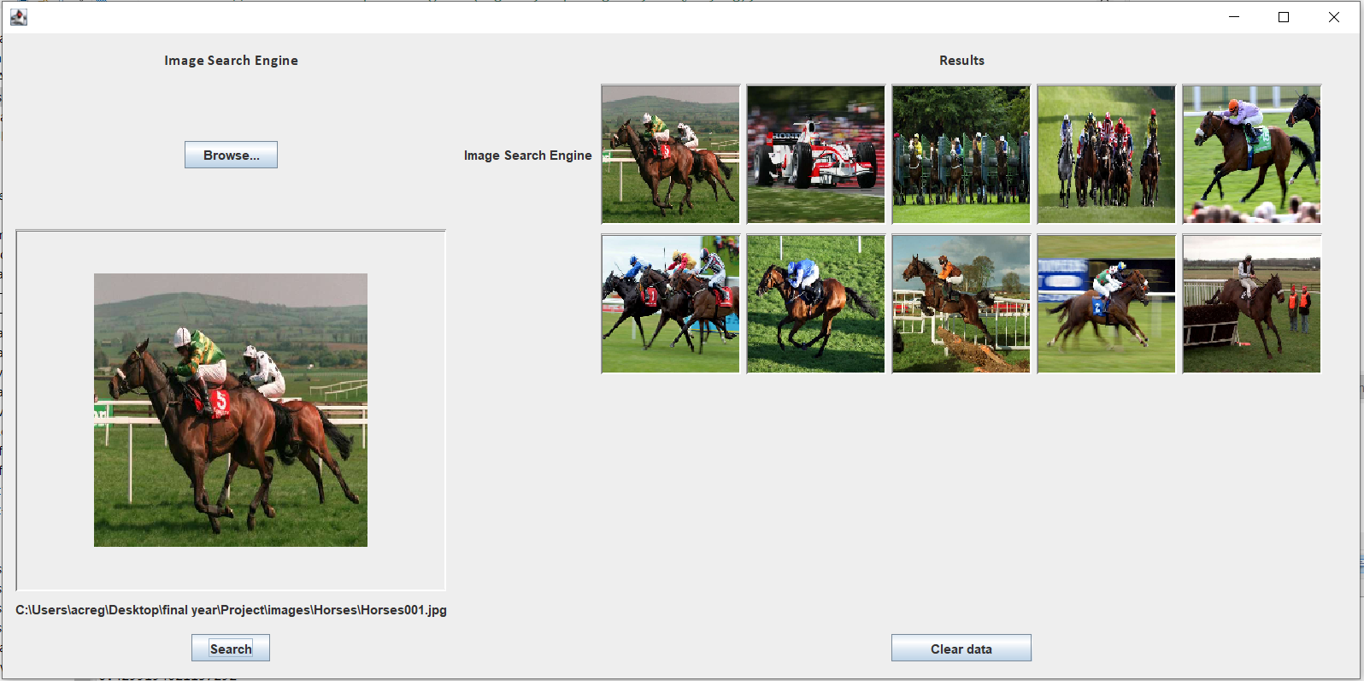
6. 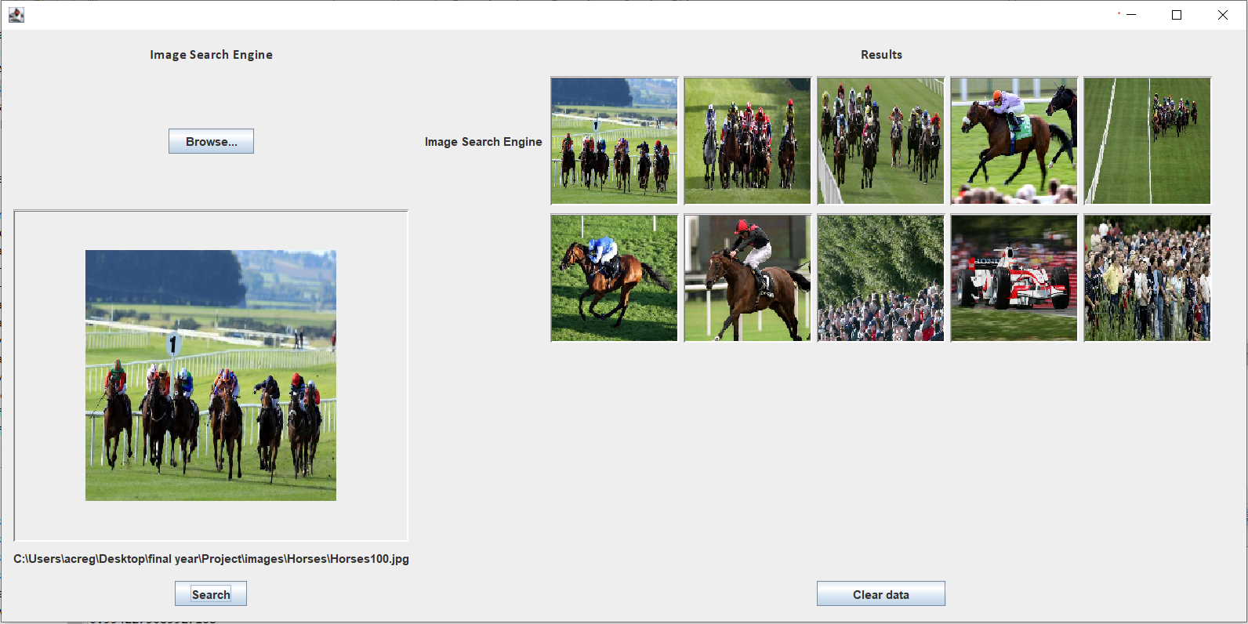
7. 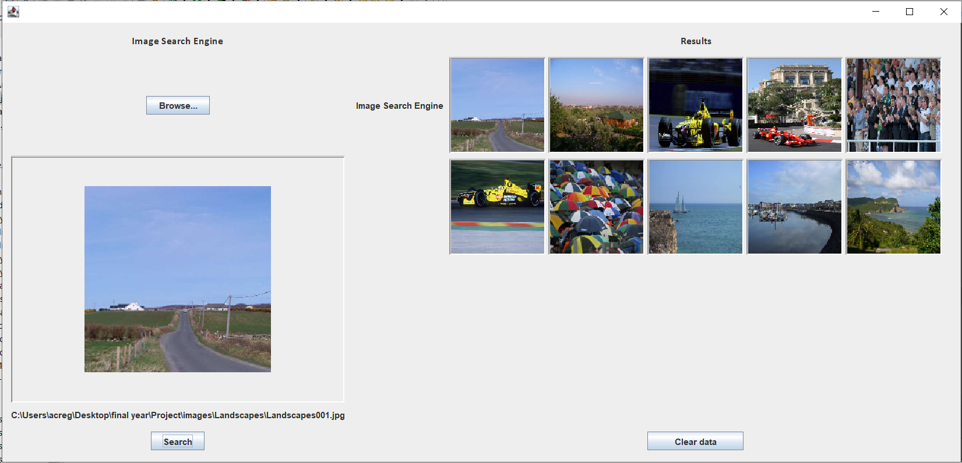
8. 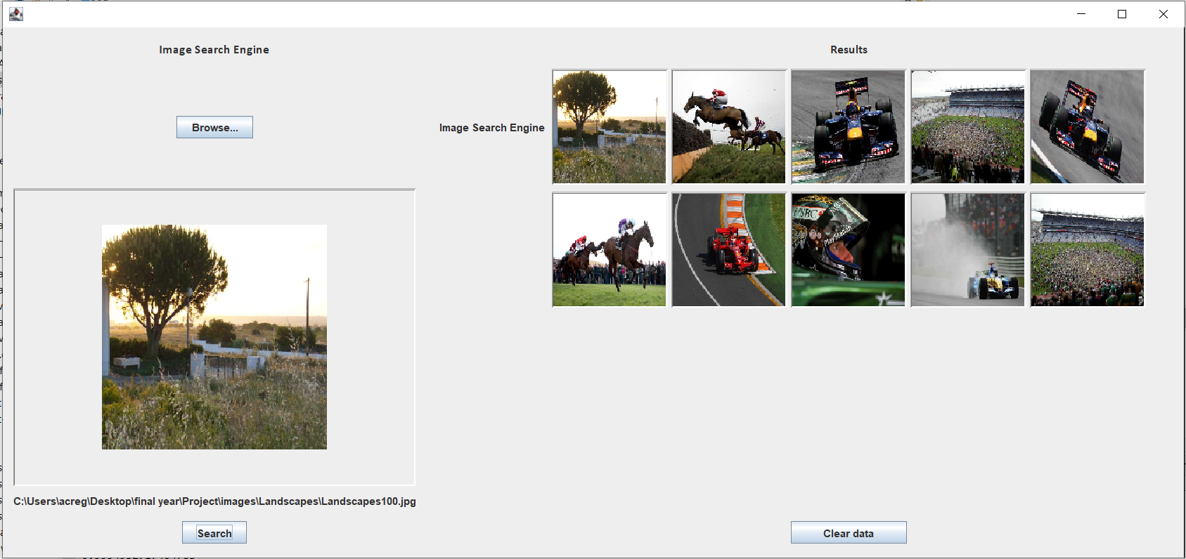

Chi-square

1. 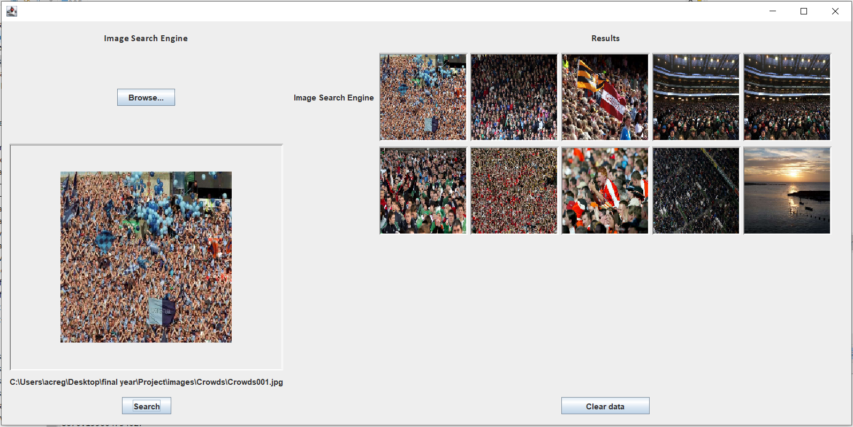
2. 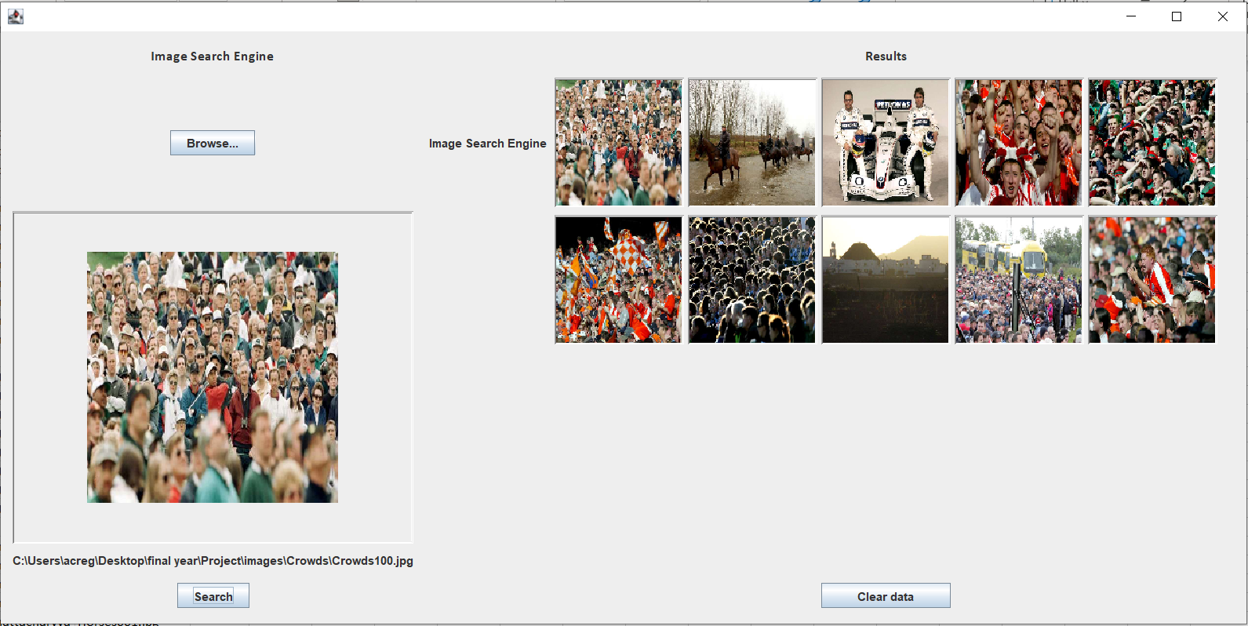
3. 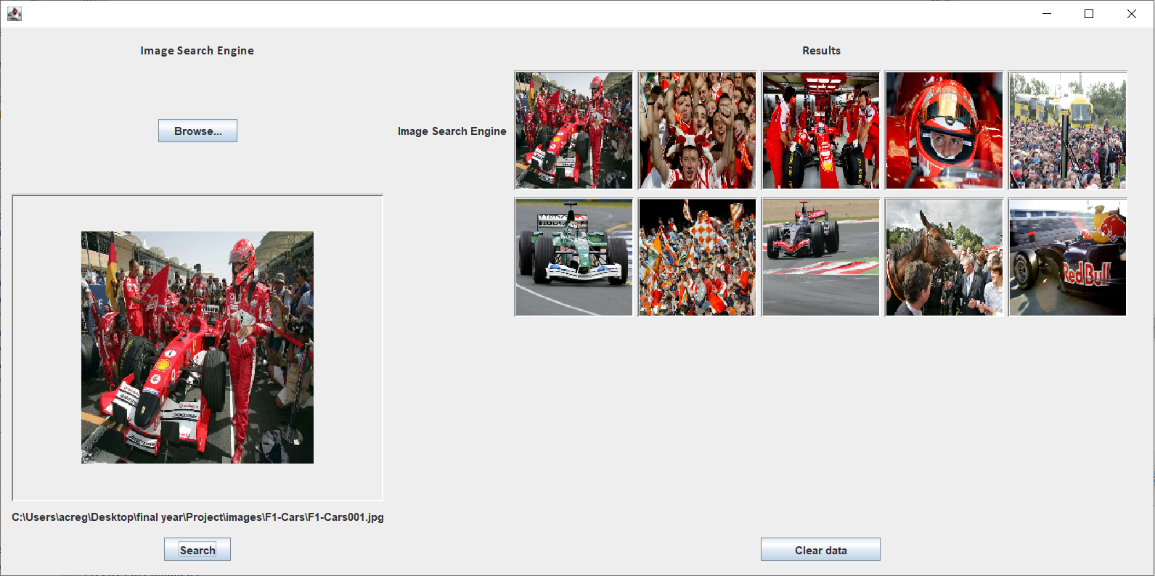
4. 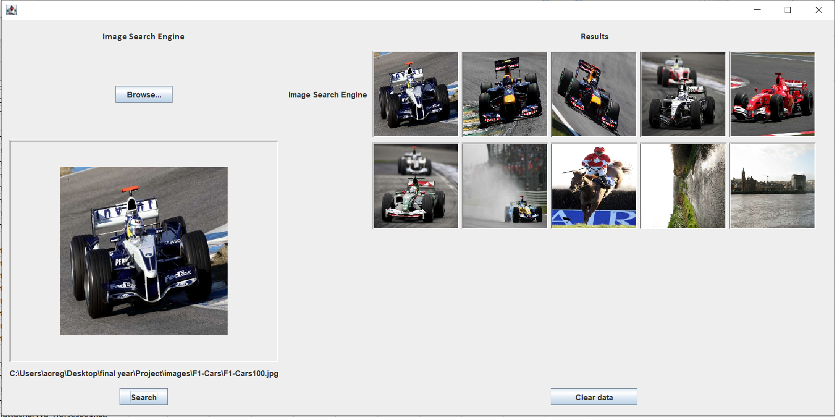

1. 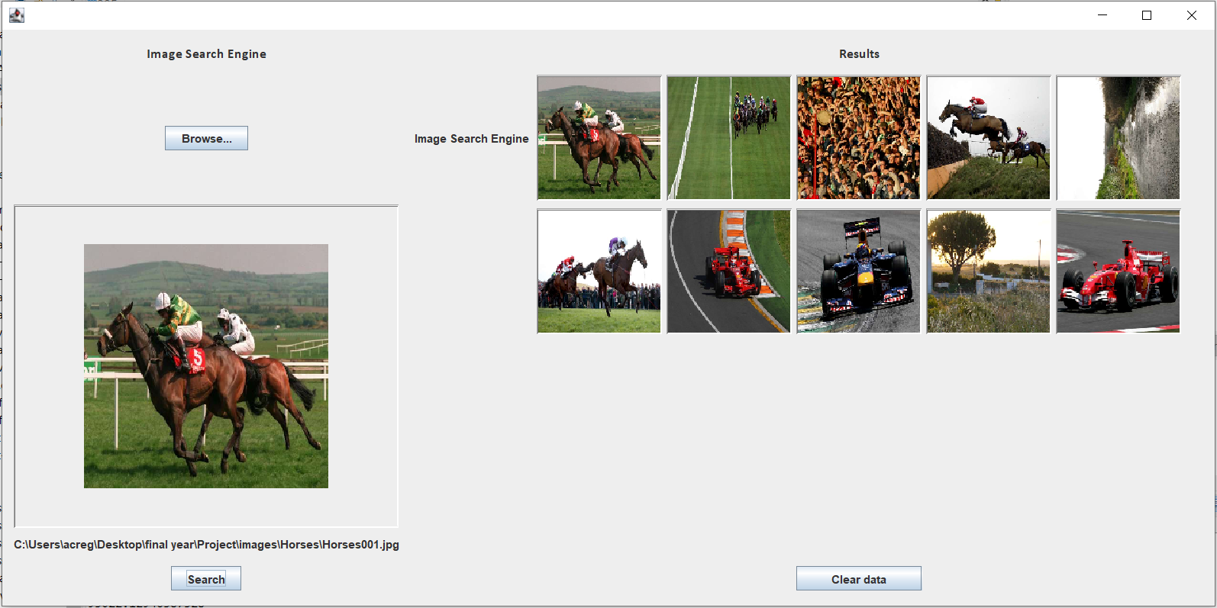
2. 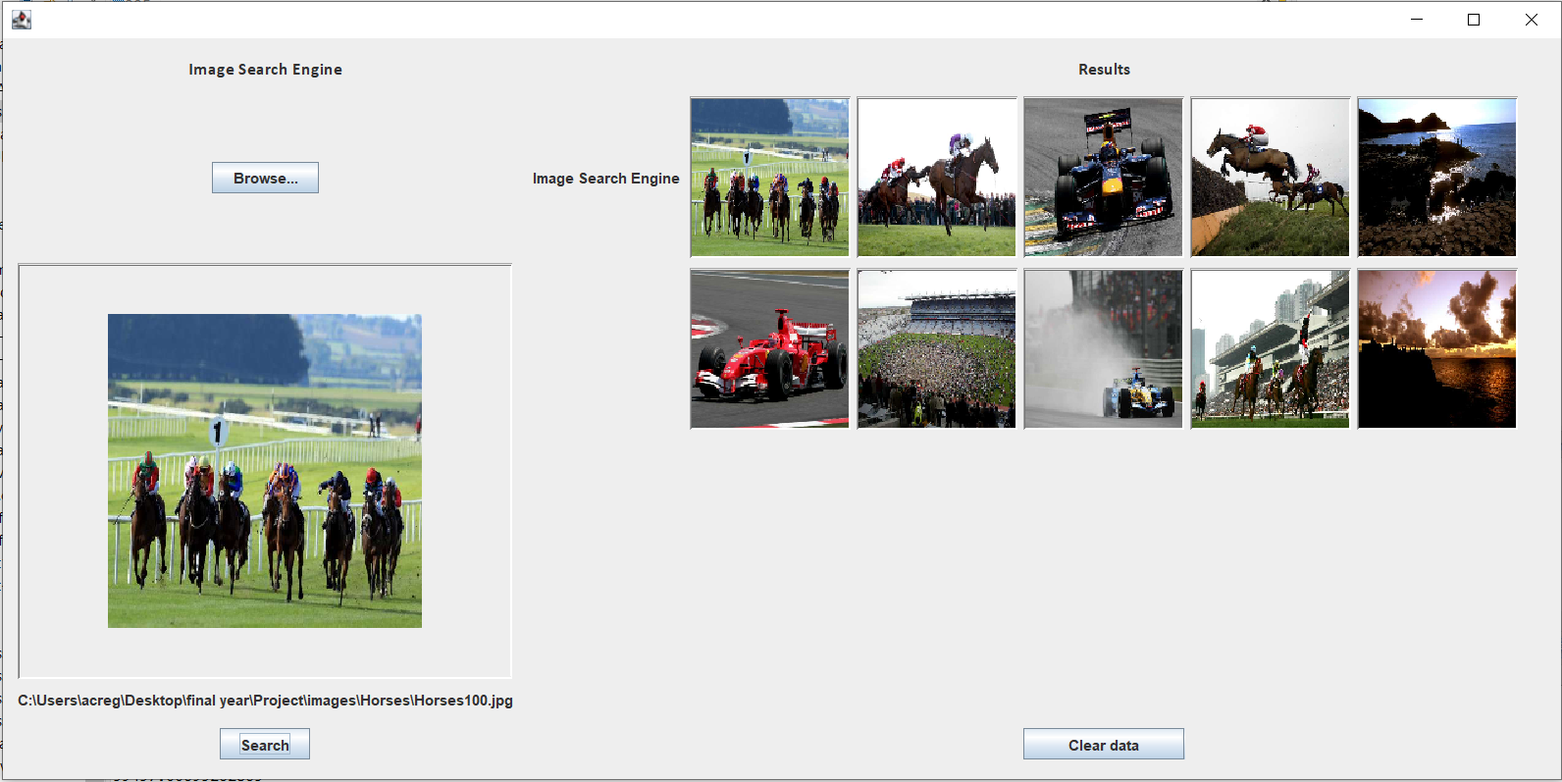
3. 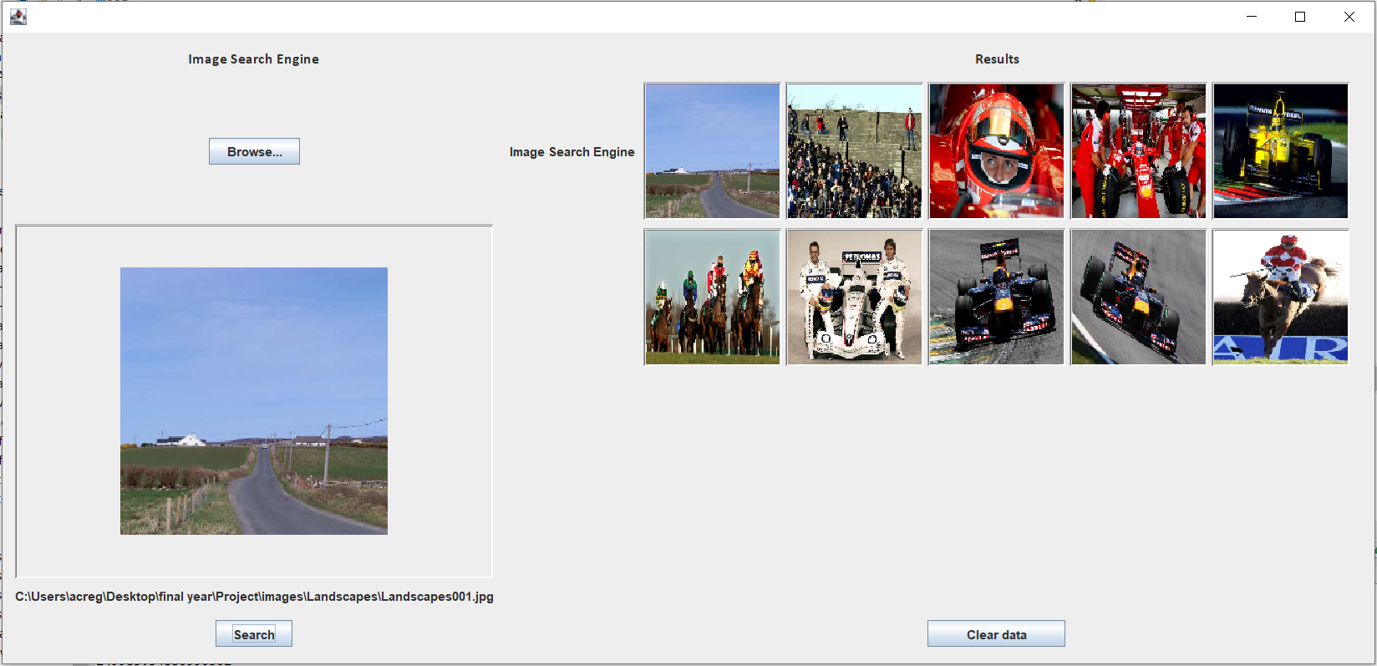
4. 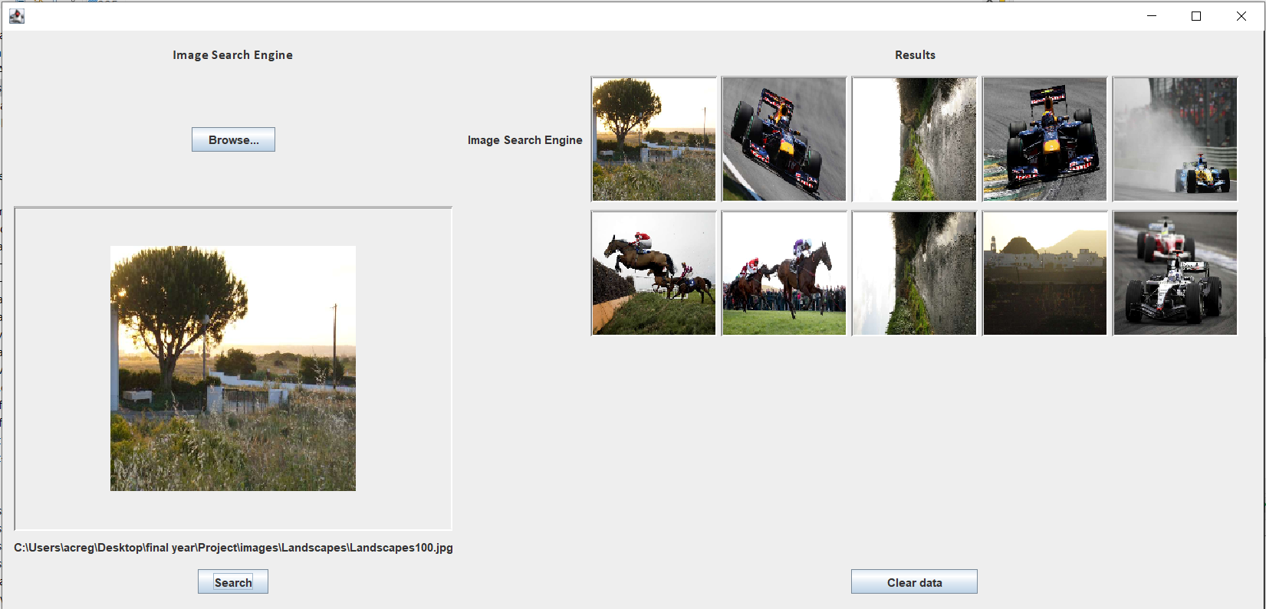

Intersection

1. 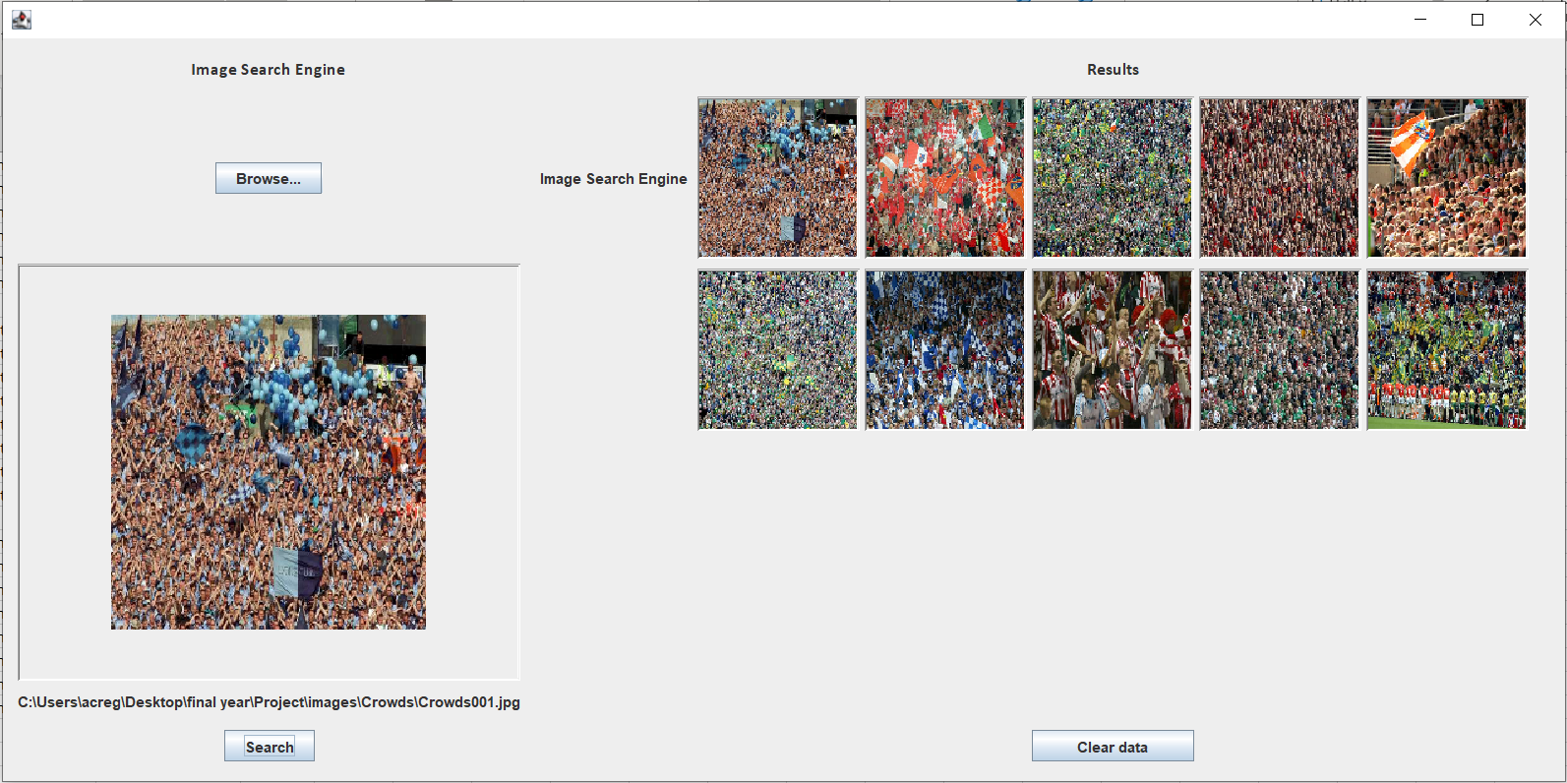
2. 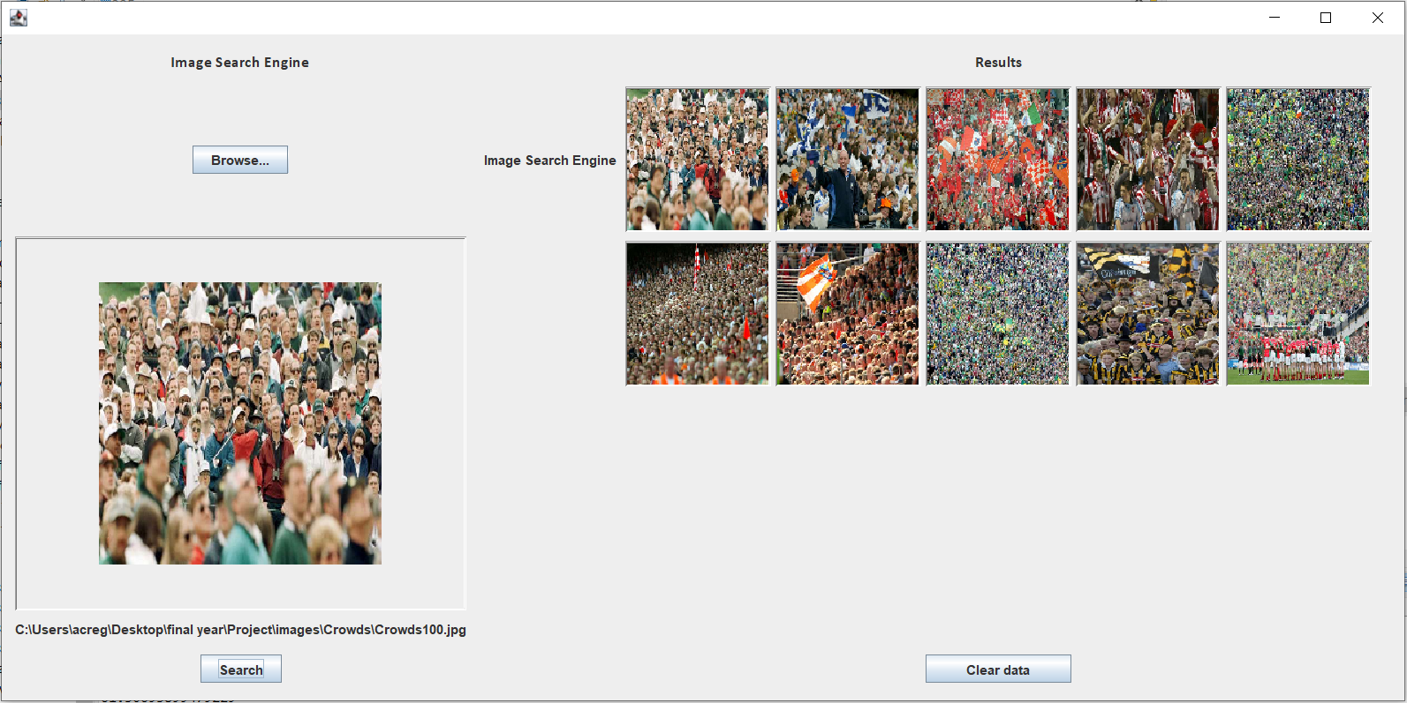
3. 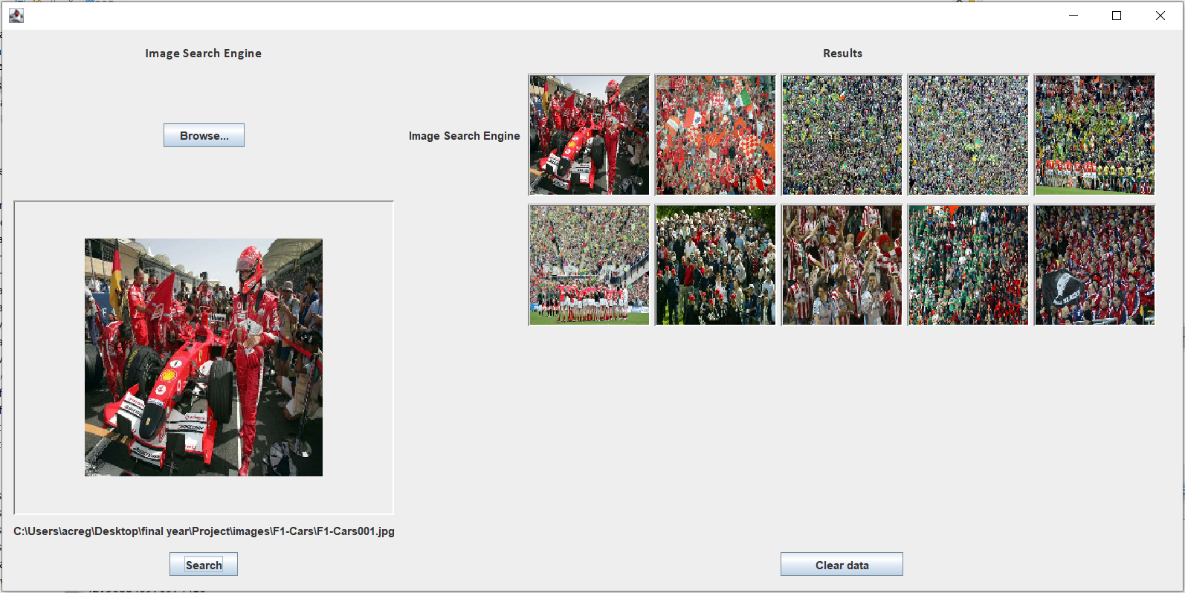
4. 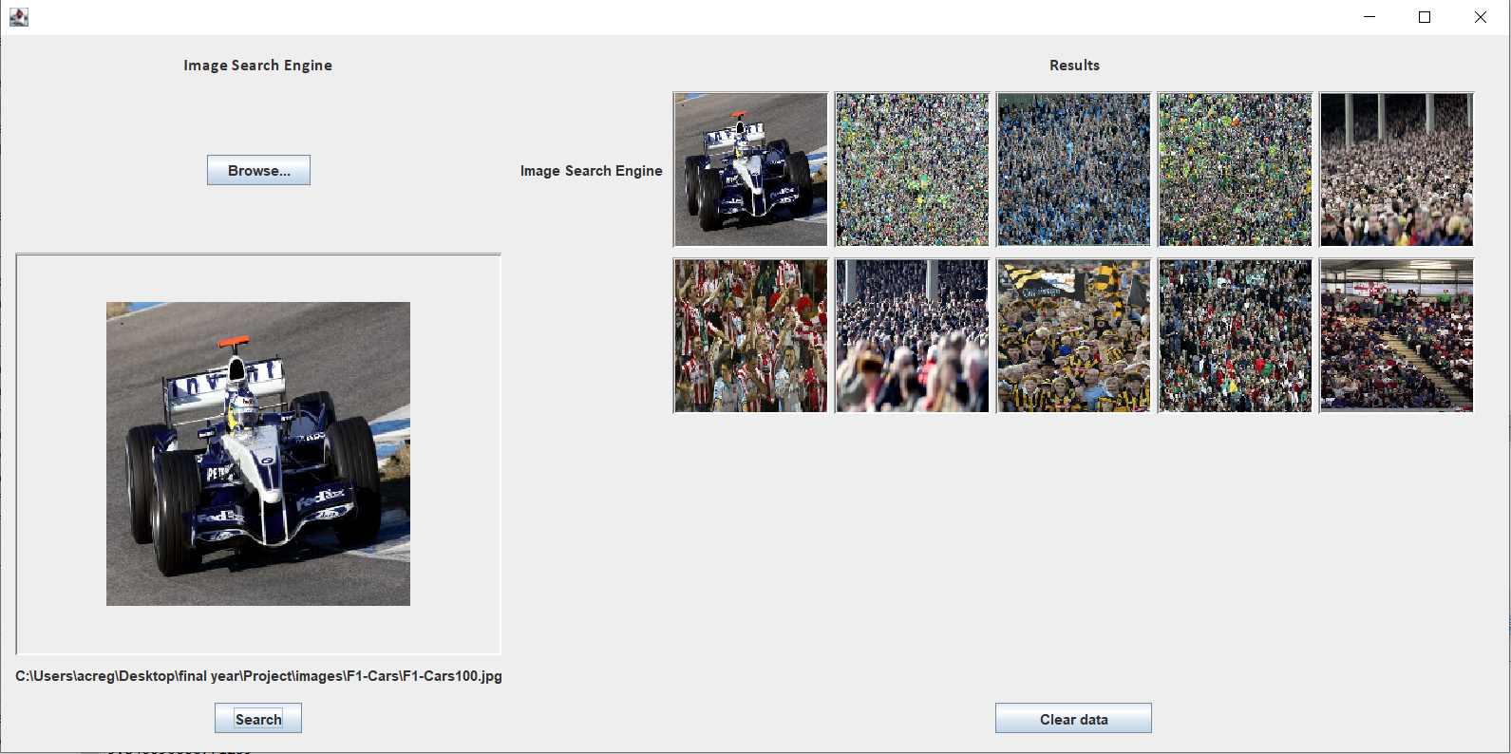
5. 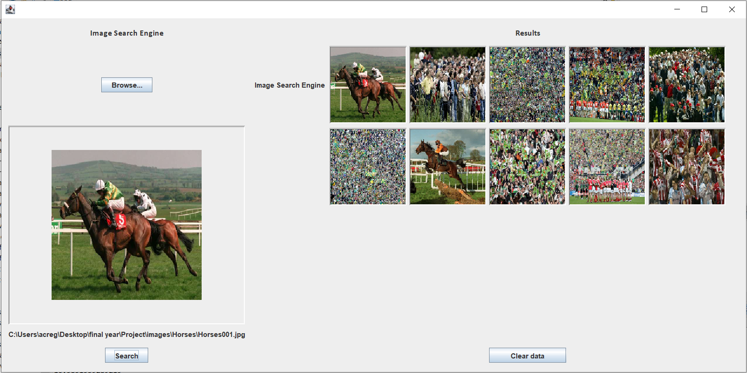
6. 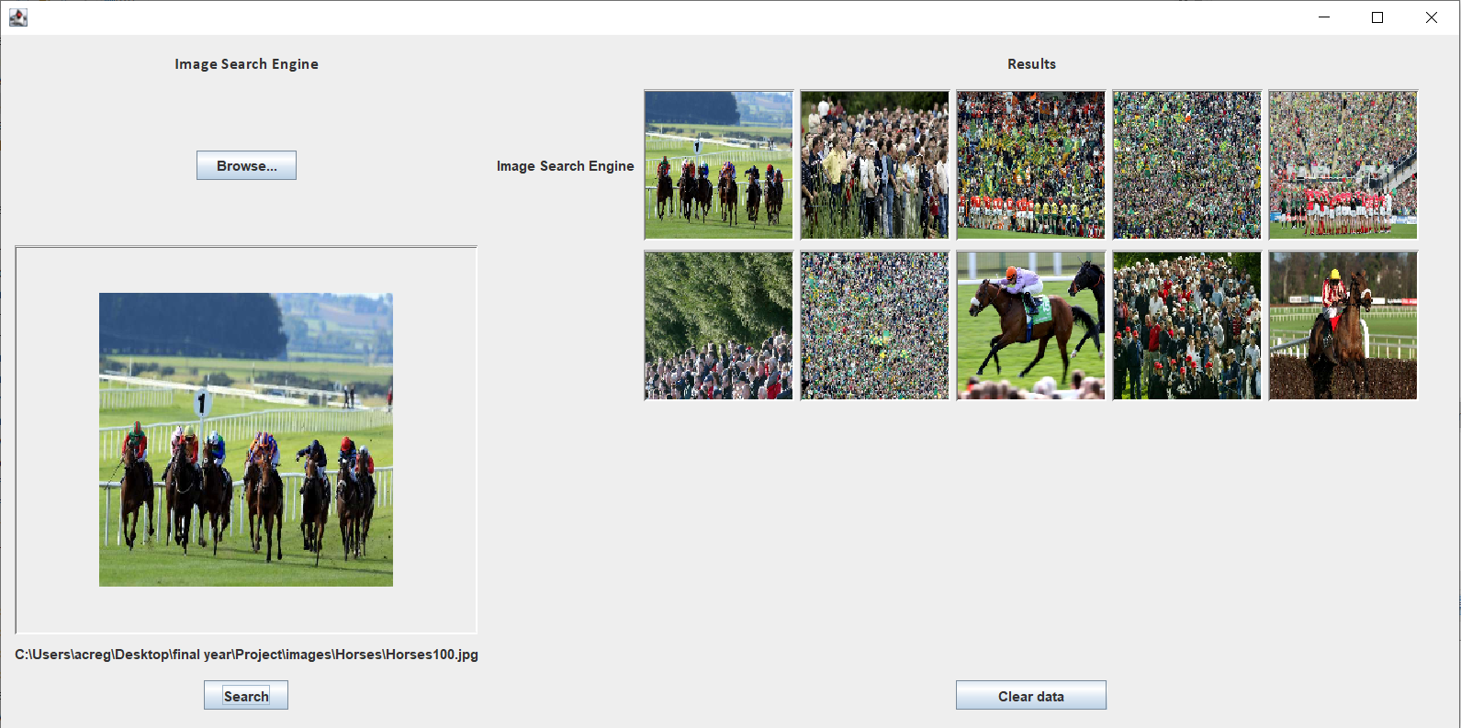
7. 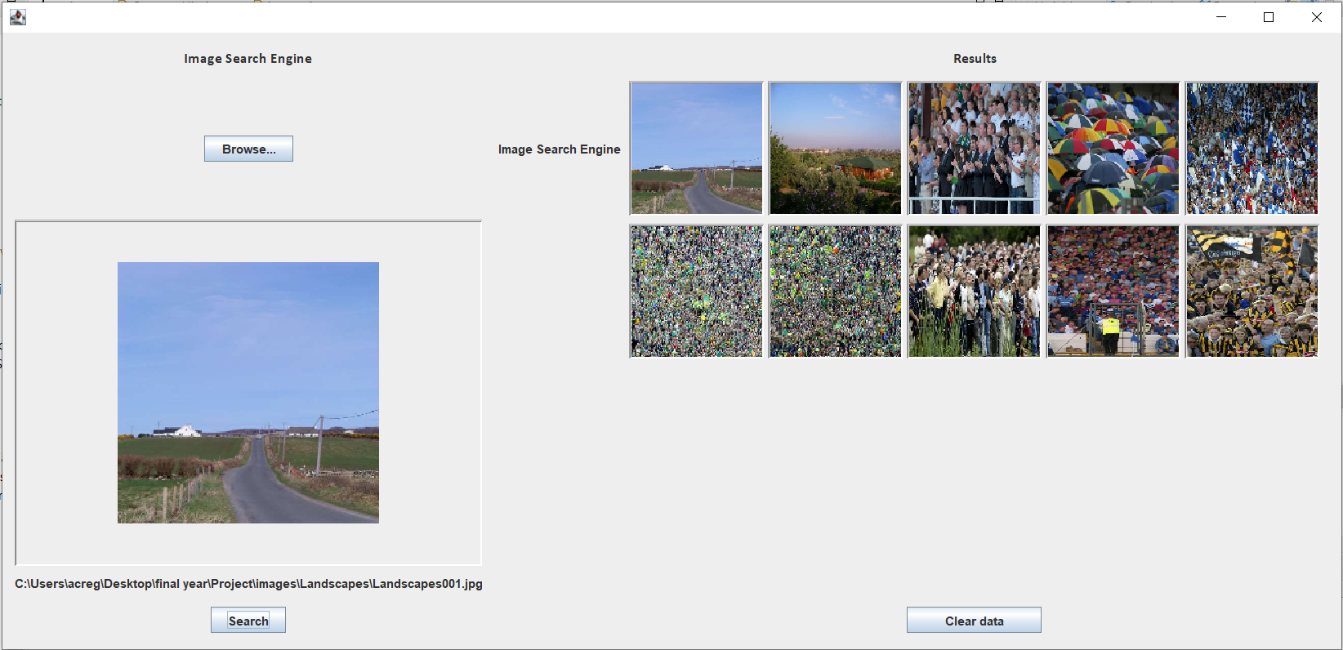

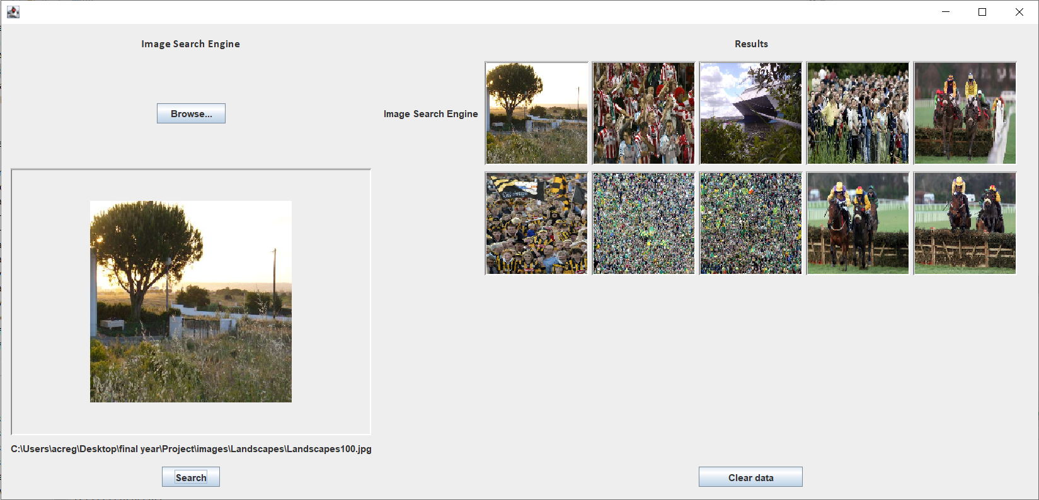

Bhattacharyya

1. 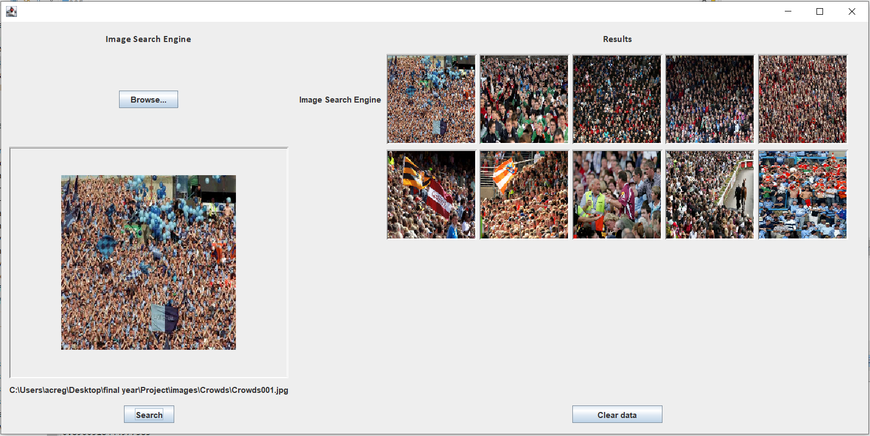
2. 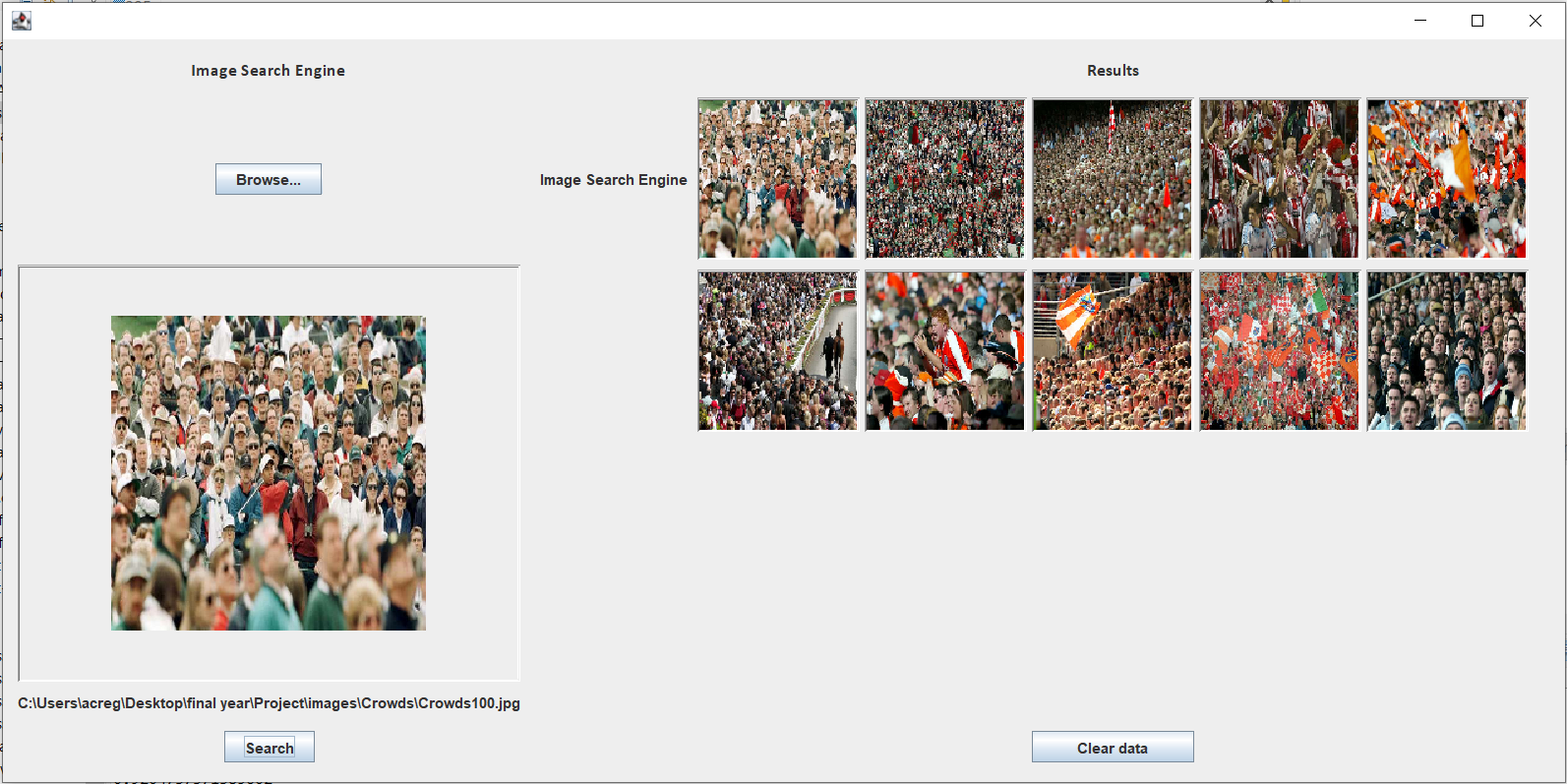
3. 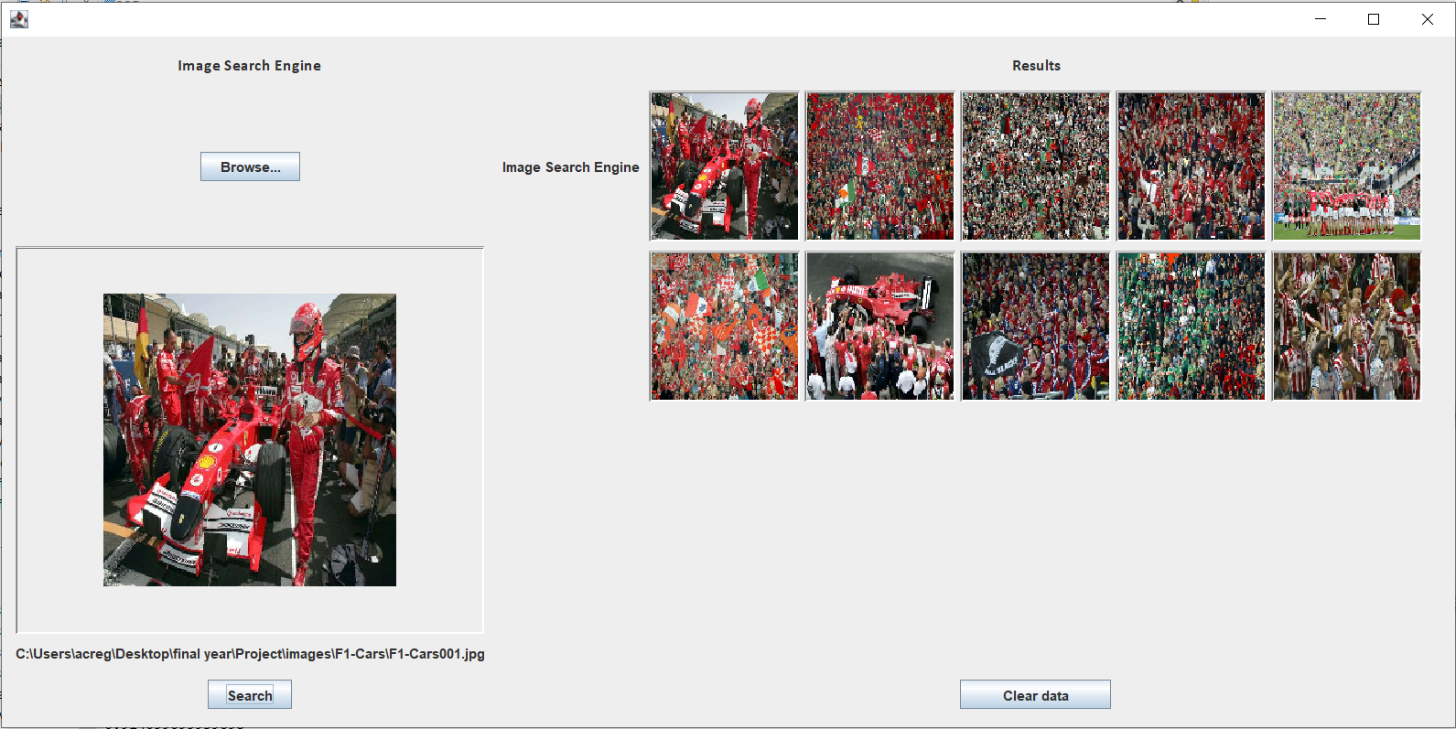
4. 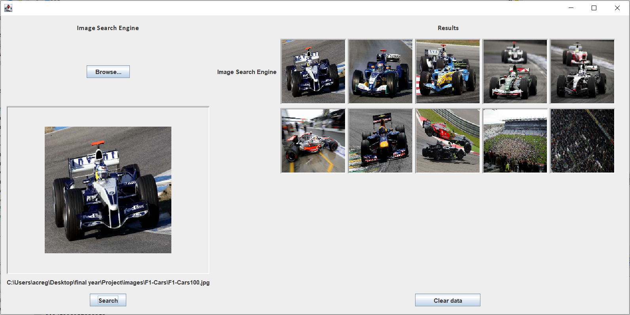
5. 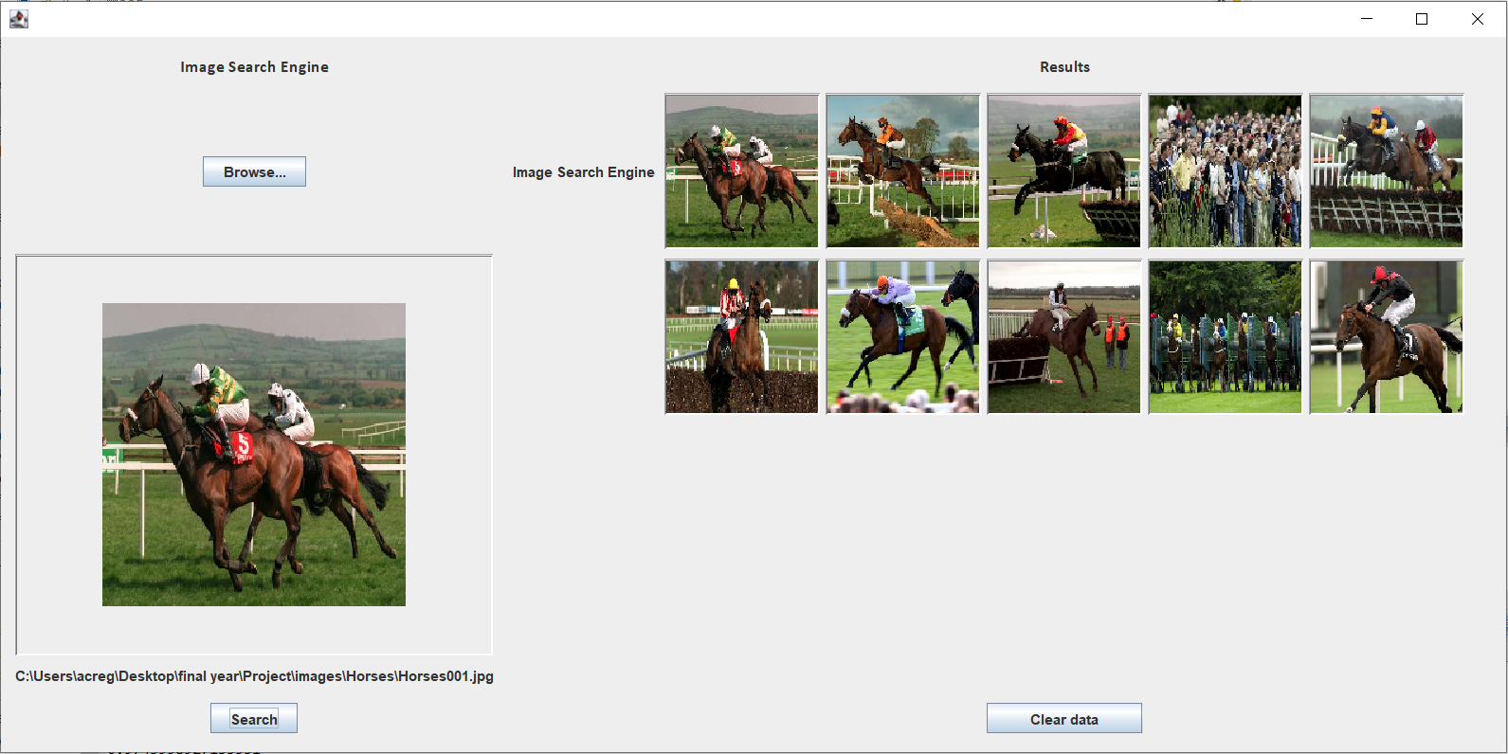
6. 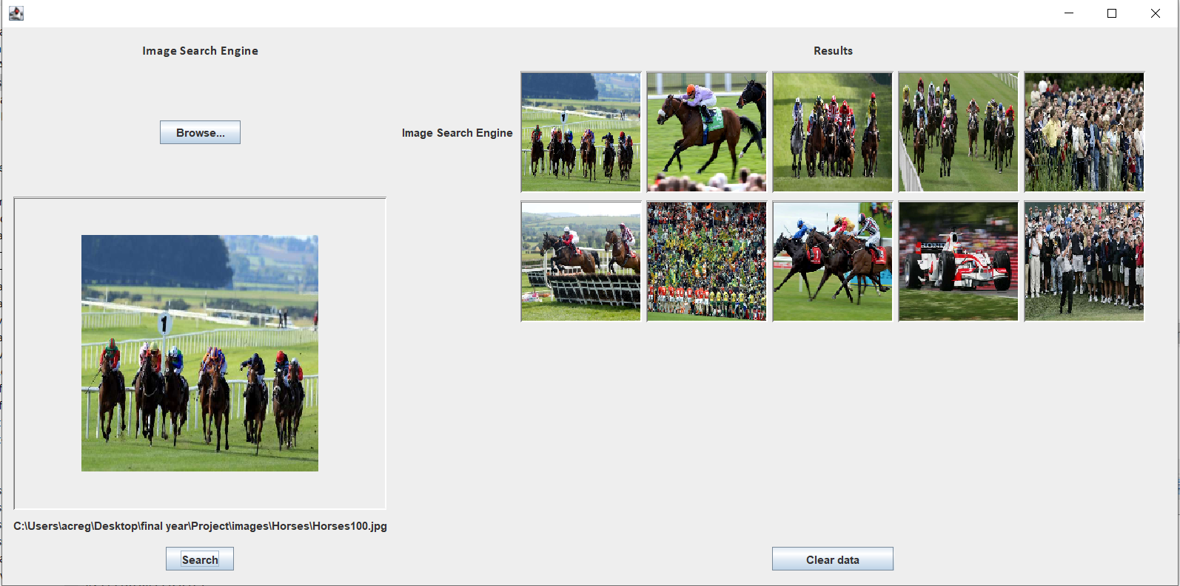
7. 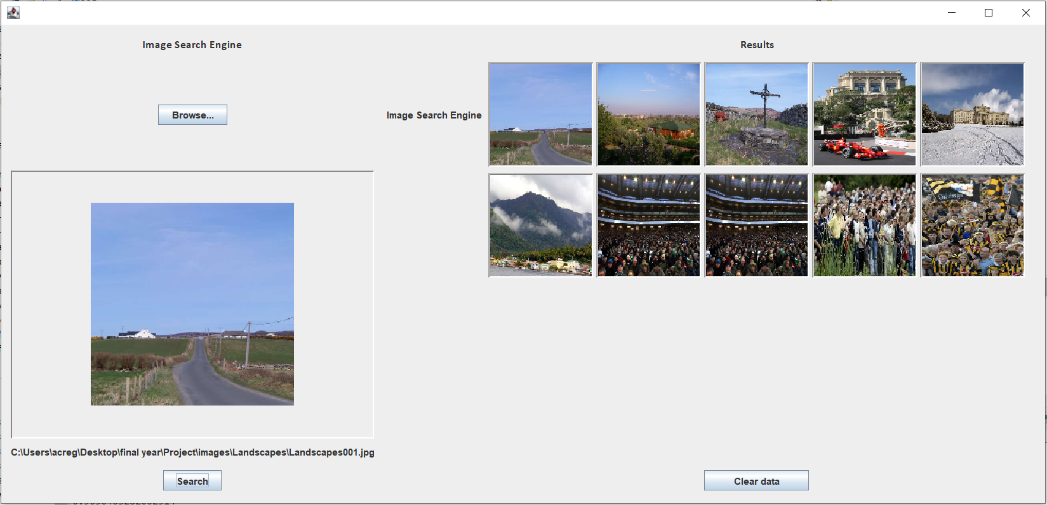
8. 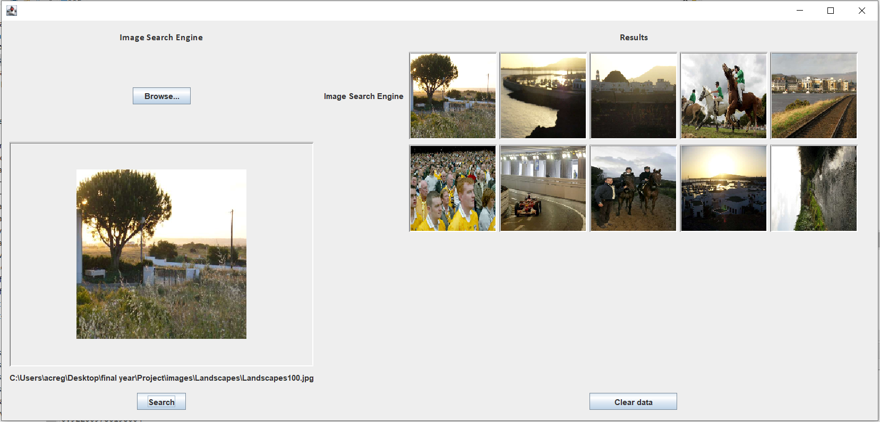

Correlation and Bhattacharyya have the best results in terms of accuracy to the label associated to the search image and image results (Crowds, F1 Cars, Horses, and Landscapes).

Averages of 65% and 70% respectively show a strong baseline of accuracy because these functions have no object detection so I would have initially guessed the results may have been lower because these methods are only dealing with colour. This means that from the test images above you can see that even the images that do not match the query image category they are still very similar in terms of colour so it would make sense for even my final search model to return images like those shown.

From here I should try to find a way to implement both of these methods with an object detection function.

The results from Chi-square and Intersection were very unimpressive in terms of label accuracy and returning images with similar colours. They will not be used in future models.